VENUE ACCESS

North Edinburgh Arts events are taking place at:

West Pilton Neighbourhood Centre
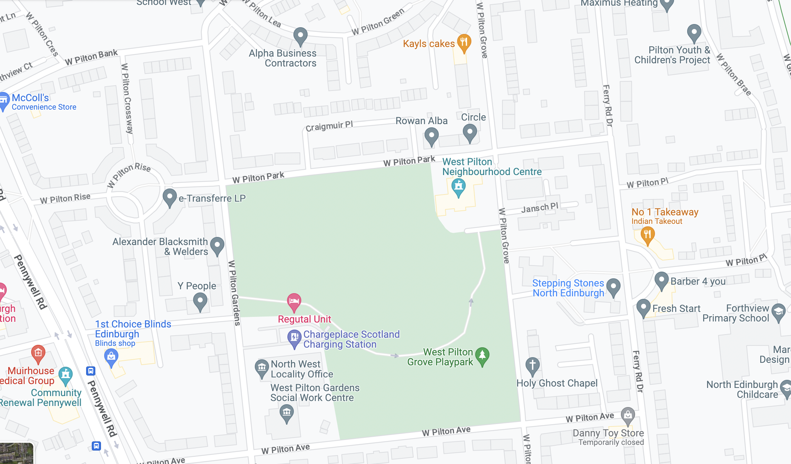
19 West Pilton Grove, Edinburgh EH4 4BY
Map of West Pilton Neighbourhood Centre, 19 West Pilton Grove, Edinburgh EH4 4BY
Phone: 0131 551 3194
• Access for wheelchair users and people with other mobility issues
• Assistance dogs welcome

Please note that venue is 6 to 10 mins after bus departure, on footpaths, and roads with speedbumps.
Lothian buses that serve this route:
Coming from north east: 7, 11, 14, 16, 21
Coming from west/south: 27, 37, 29

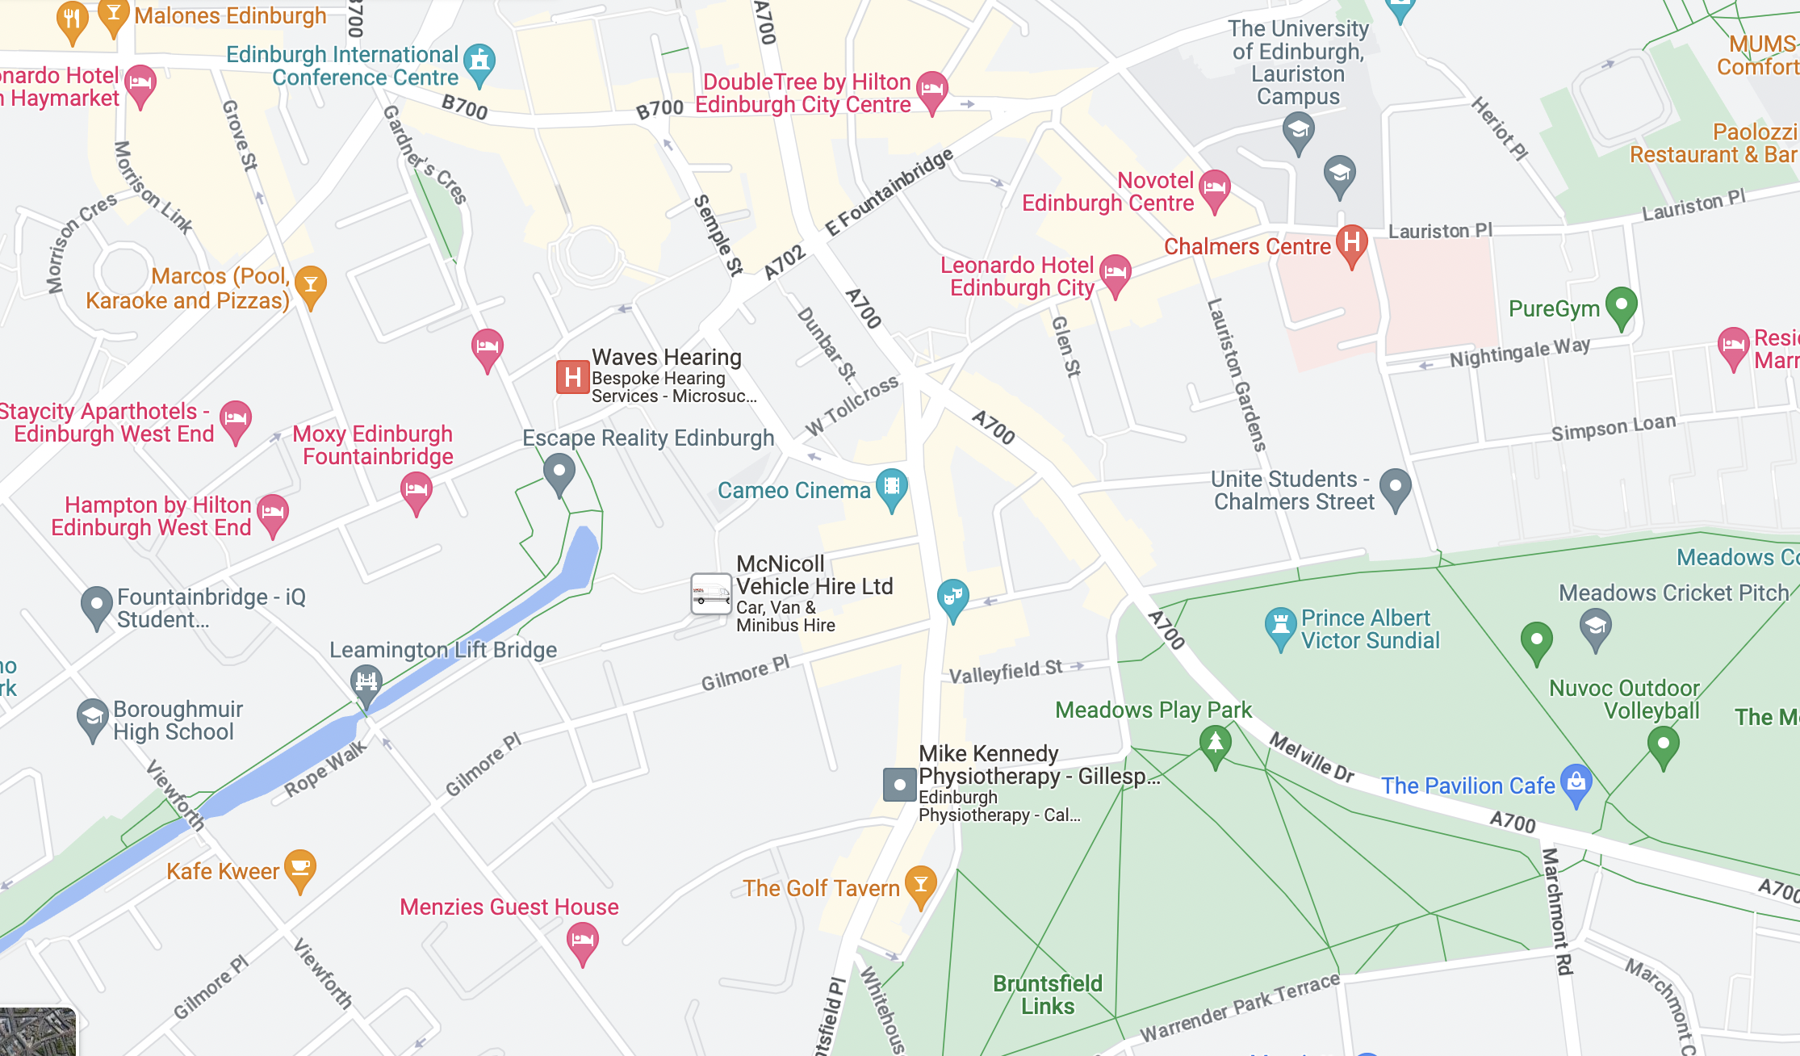
Cameo Picturehouse Cinema
38 Home St, Edinburgh EH3 9LZ
Map of Cameo Picturehouse Cinema
38 Home St, Edinburgh EH3 9LZ
Phone: 020 7326 2649
Accessibility Hotline: 02072 947908
Text Relay call: 18001 02072 947908
Website: https://www.picturehouses.com/cinema/the-cameo/accessibility

• Access for wheelchair users and people with other mobility issues
- Assistance dogs welcome
- Induction loops available
Lothian buses that serve this route:
Coming from west: 3, 4, 33
Coming from south west: 5, 11, 16, 23
Coming from the north: 14, 16, 25 and 35

Scottish Storytelling Centre

43-45 High Street, Edinburgh, Scotland EH1 1SR
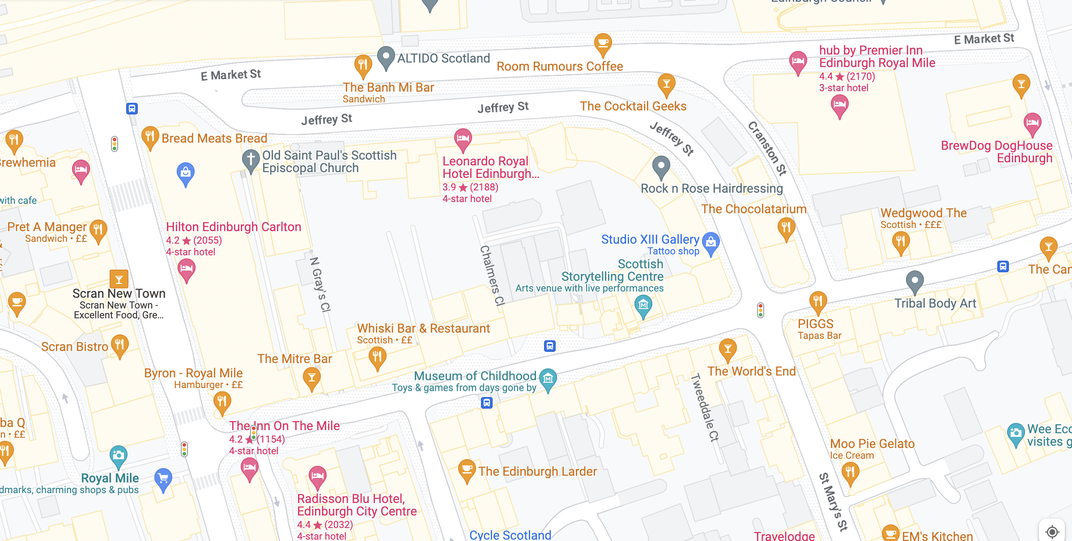
Map of Scottish Storytelling Centre, 43-45 High Street, Edinburgh, Scotland, EH1 1SR
Phone: 0131 556 9579
Box Office Email: reception@scottishstorytellingcentre.com
Website: https://scottishstorytellingcentre.online.red61.co.uk/contact/

• Access for wheelchair users and people with other mobility issues
- Assistance dogs welcome
- Induction loops available
Lothian buses that serve this route:

Coming from west: 3, 4, 33
Coming from south west: 5, 11, 16, 23
Coming from the north: 14, 16, 25 and 35

