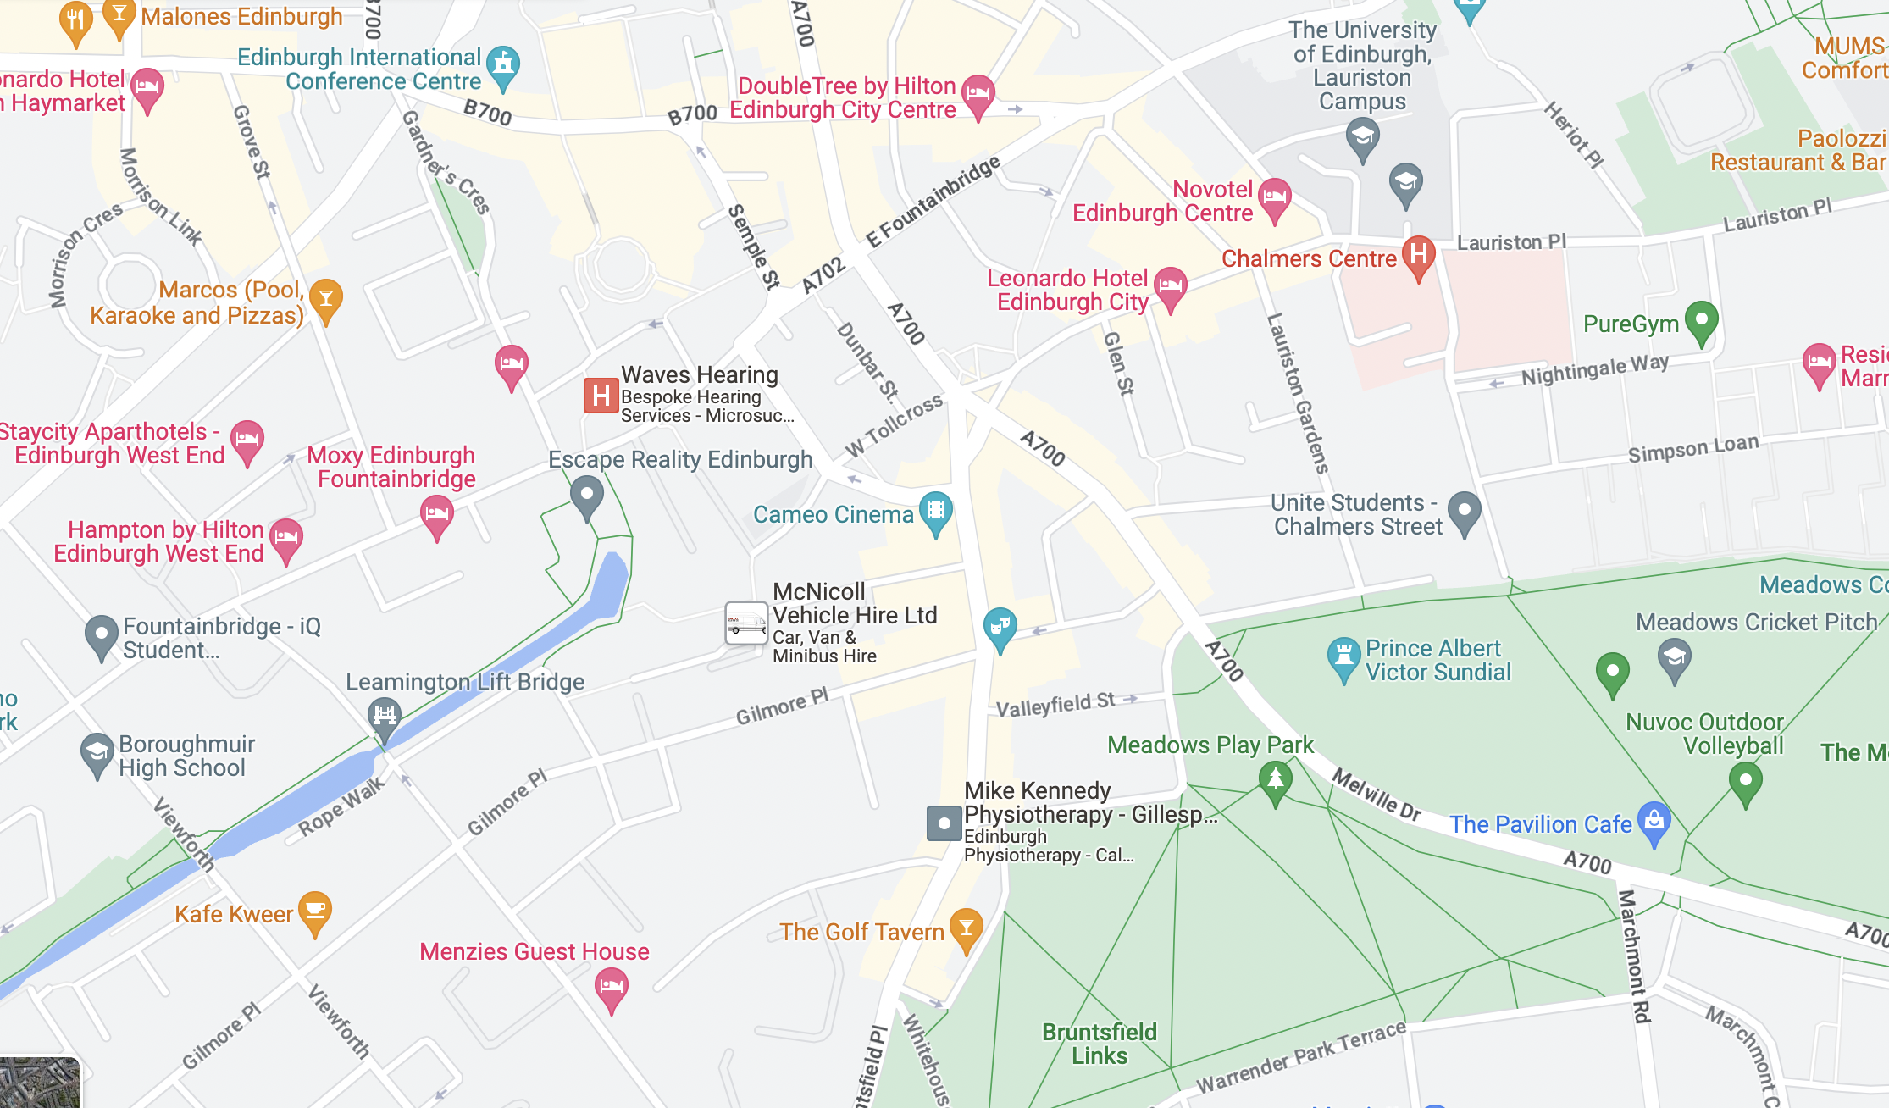
Cameo Picturehouse Cinema
38 Home St, Edinburgh EH3 9LZ
Map of Cameo Picturehouse Cinema
38 Home St, Edinburgh EH3 9LZ

Phone: 020 7326 2649
Accessibility Hotline: 02072 947908
Text Relay call: 18001 02072 947908
Website: https://www.picturehouses.com/cinema/the-cameo/accessibility

• Access for wheelchair users and people with other mobility issues
- Assistance dogs welcome
- Induction loops available
Lothian buses that serve this route:
Coming from west: 3, 4, 33
Coming from south west: 5, 11, 16, 23
Coming from the north: 14, 16, 25 and 35

Scottish Storytelling Centre

43-45 High Street, Edinburgh, Scotland EH1 1SR
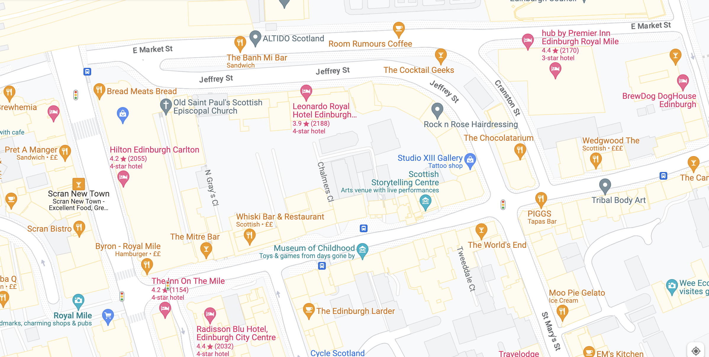
Map of Scottish Storytelling Centre, 43-45 High Street, Edinburgh, Scotland, EH1 1SR
Phone: 0131 556 9579
Box Office Email: reception@scottishstorytellingcentre.com
Website: https://scottishstorytellingcentre.online.red61.co.uk/contact/

• Access for wheelchair users and people with other mobility issues
- Assistance dogs welcome
- Induction loops available
Lothian buses that serve this route:

Coming from west: 3, 4, 33
Coming from south west: 5, 11, 16, 23
Coming from the north: 14, 16, 25 and 35

North Edinburgh Arts
12C MacMillan Square, Edinburgh, EH4 4AB

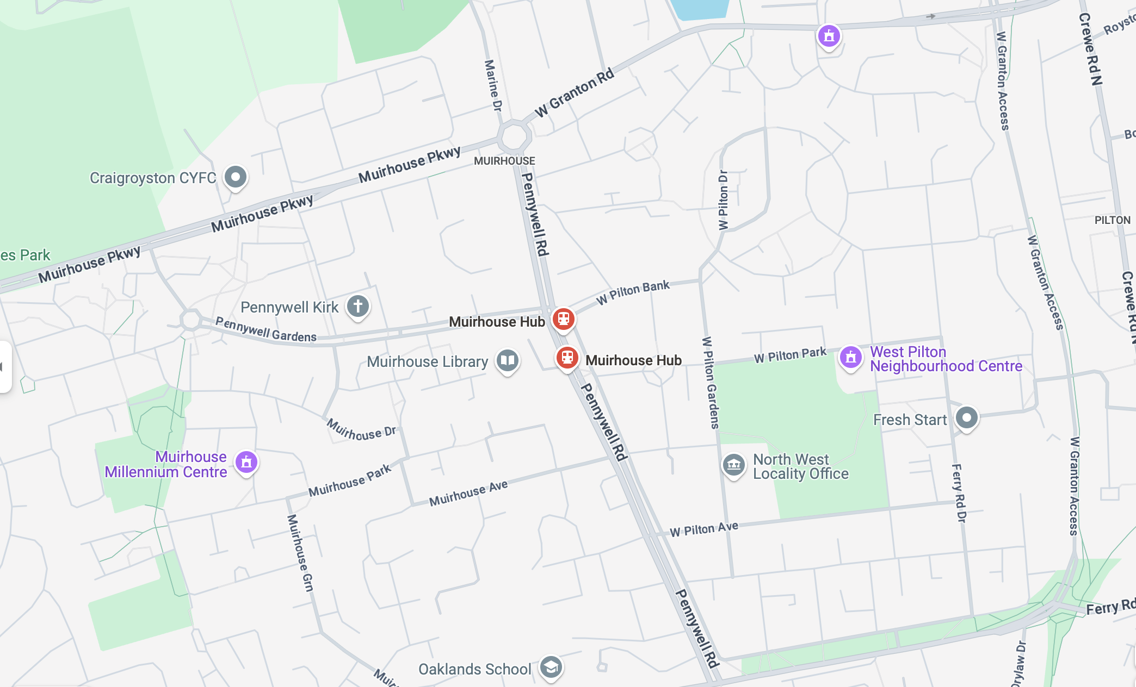

Phone: 0131 315 2151
Box Office Email: admin@northedinburgharts.co.uk
Website: https://northedinburgharts.co.uk/contact-us/
what3words: ///intervals.after.loud

Lothian buses that serve this route:
Pennywell Gardens – 14
Pennywell Road – 27, 37, 24, 200
Ferry Road – 21, 29

